ADa – star schema Your Name:

For the model below:

List 3 queries that an investor in ProjectIT may want to know:

No of projects renewed per year
How many new consultants per month
How many new projects per year
Avg actual salary all projects per year
No of projects led by project manager per year
Amount of revenue (total salary) per account per year
No_of_potential consultants per job role per year
No_of projects secured per year
No_new_accounts per project manager per year

No-consultants per skill set per year
No-consultants without projects per year
No_consultants per account per year/month/quarter

No-consultants per salary_band per job_role per year

Star Methodology (consider using this for your assignment…)

List & clarify relevant business question(s) that need to be answered for the Investor

Eg, investigate skills sets required
Investigate skill sets of consultants

What Dimension tables are required (name them eg time_dim)

Time_dim
Skill_set_dim

Identify lowest level of granularity (for each Dimension)

Quarter/month/year

Identify the measures to support the business questions (calculations or facts)

COUNT / SUM/ AVG

MAX/MIN

Algorithm – SUM/COUNT %

Define (name, data type) suitable attributes of the Dimension tables

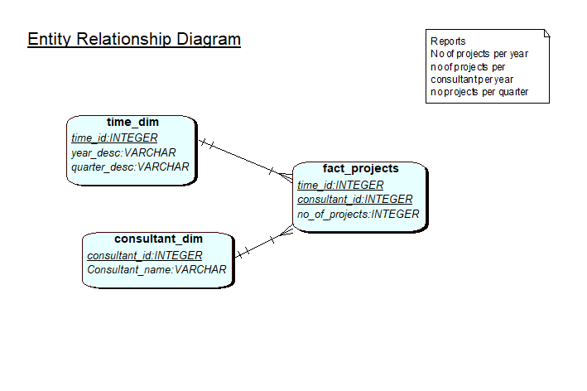

Define (name, data type) the Fact table (keys and measures)

As above

Draw the Star Schema (using QSEE) and create a table (in word) to illustrate the data for each table in the star schema.

As above

Create a data dictionary to document each of the tables in the star schema model.
Show where each piece of data in the star schema comes from (from the ProjectIT leeds and manchester systems), describe mappings and transformations.
Research data dictionaries and add to the data dictionary metadata that would be valuable.

Look into crisp methodology

Data in tables to support reports above in star schema

Time_dim
1 | 2013 | 1
2 | 2013 | 2
3 | 2013 | 3
4 | 2013 | 4
5 | 2014 | 1
6 | 2014 | 2
7 | 2014 | 3
8 | 2014 | 4
9 | 2015 | 1
10 | 2015 | 2
11 | 2015 | 3
12 | 2015 | 4
100 | 2014 | Null  To deal with report of all projects per year

Contractor_dim (cont_id, original_id, con_desc)
1 | 10 | Liam Love
2 | 11 | Mandy More
3 | 12 | Neil Noel
4 |  | ….
Added surrogate key in case we have consultants with the same id in both lds and SkillUp | … also add consultants from Manchester  Problem with ids …

Fact_project
Report_id, Time_id, consultant_id, no_of_projects
1 | 1 | 10 | !!! work it out - 2
2 | 2 | 10 | 0
3 | 3 | 10 | 0
4 | ….
Added surrogate key so we can have reports for ‘all consultants’ | 1 | 11
 | 2 | 11
 | 3 | 11
100 | 100 | 10 | 4
101 | 100 | null | 250

Data dictionary – on per table
Research …

Time_dim
column | datatype | constraints | Data source | Check?
Time_id | Integer(2) | Not null, key | sequence
Year_desc | Varchar2(4) |  | Automatic – with update/ maintenance  OR  From project_start_date on lds_project | ‘first’ not ‘1’

Predicted table size
Access paths
How data is maintained?
Data uploaded?
SCD ---

Look online and see what else to include in your DD, Data warehousing dimensions and facts.

